CRYPTOCURRENCY PRICE TRACKER
Automated Web Scraping & Historical Data Logging

MINI PROJECT REPORT
SUBMITTED BY: B.ABARNA

1.Introduction
The Cryptocurrency Price Tracker is a Python-based application that automatically collects cryptocurrency market data using Selenium. It extracts the coin name, current price, 24h change, and market cap, and stores the data with timestamps in a CSV file for historical tracking.

2. Project Overview
Simple, automated cryptocurrency market data collection
- Python-based web scraping application using Selenium WebDriver.
- Collects the top 10 cryptocurrency records available on Coin Gecko.
- Extracts Coin Name, Current Price, 24h Change and Market Cap.
- Adds a timestamp to every collection run.
- Stores current and historical records in crypto_prices.csv.
- Provides a simple filter for coins with 24h Change greater than 5%.

3. Problem Statement
Manual Monitoring
Users need to repeatedly visit cryptocurrency websites and record changing values.
Historical Records
Maintaining previous market observations manually is difficult.
Quick Filtering
Finding coins with significant 24-hour changes takes extra effort.
- The proposed application automates these repetitive tasks and stores the collected information in a structured format.
4. Objectives
- Automate cryptocurrency data collection.
- Use Selenium to handle dynamically loaded webpages.
- Extract the top 10 cryptocurrency records.
- Process the extracted data using Pandas.
- Store records in CSV format with timestamps.
- Maintain historical data across multiple runs.
- Identify coins with 24h Change above 5%.

5. Technologies Used
Python
Main programming language
Selenium
Chrome browser automation
Pandas
Data Frame & data processing
WebDriver Manager
Automatic Chrome Driver setup
Google Chrome
Browser controlled by Selenium
CSV
Historical data storage

6. System Workflow
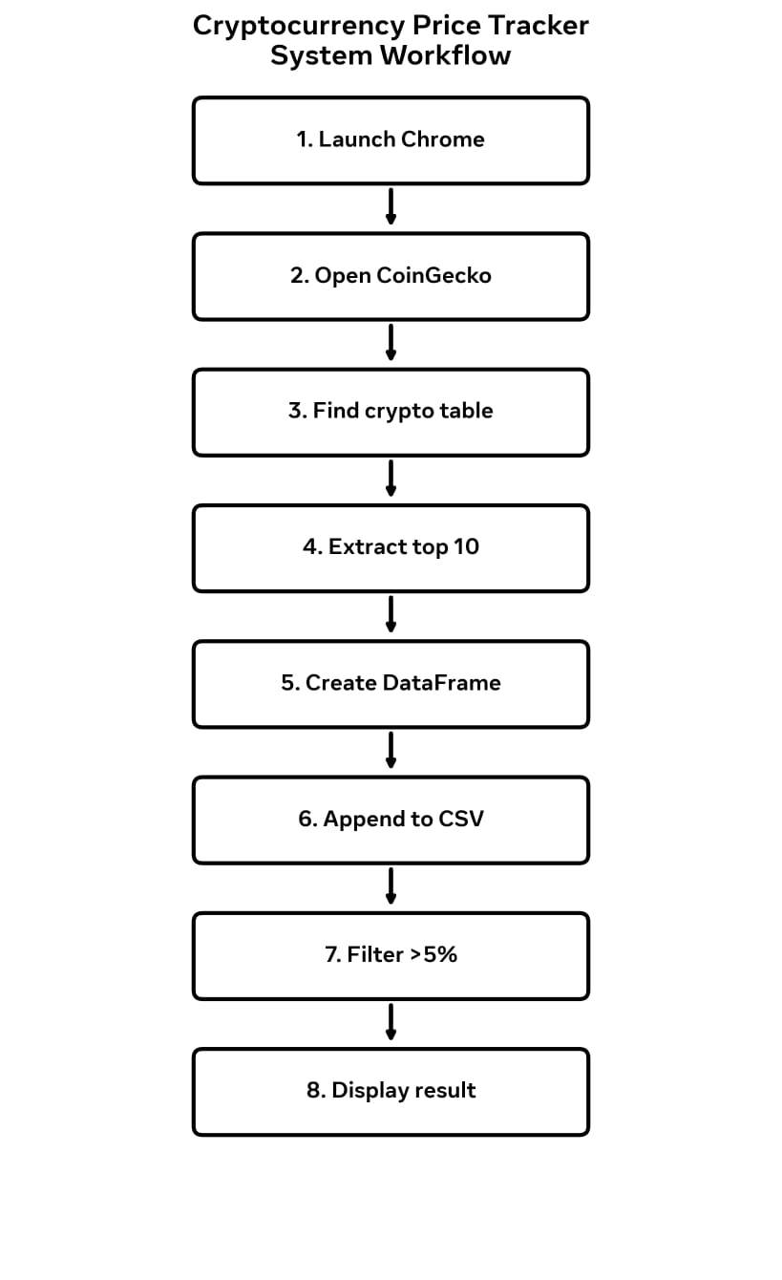
7. Data Collected
Fields stored in crypto_prices.csv
Timestamp
Collection date & time
Coin Name
Cryptocurrency identifier
Current Price
Displayed current price
24h Change
24-hour percentage change
Market Cap
Market capitalization

8. Implementation Highlights
Browser Automation
Selenium launches Chrome, opens Coin Gecko and waits for the dynamic table to load.
Top 10 Extraction
The first 10 table rows are processed and the required columns are extracted.
Historical Logging
Existing CSV data is read and combined with the new Data Frame.
Filtering
24h Change values are converted to numbers and filtered using > 5%.

9. Project Output
Historical CSV data generated by the application
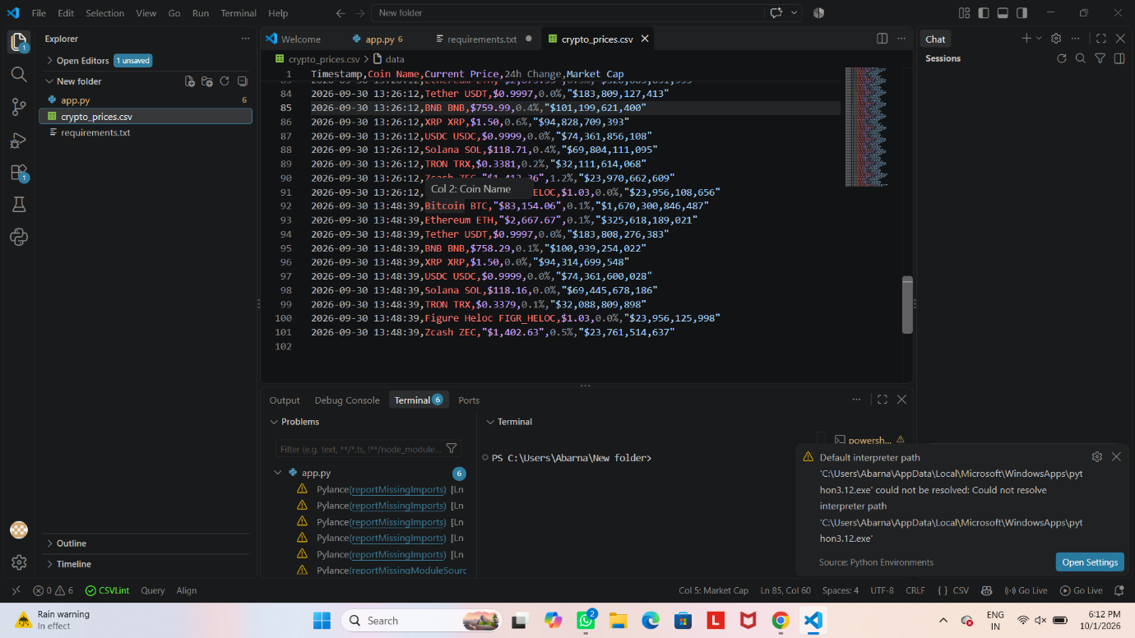

10. CSV Storage & Historical Logging
File Name
crypto_prices.csv
Each run adds new timestamped records while preserving previous data.
Historical Benefit
Multiple runs can be compared later for trend analysis and visualization.
Sample Columns
Timestamp | Coin Name | Current Price | 24h Change | Market Cap

11. Key Features
- Live webpage scraping
- Dynamic page handling using Selenium
- Top 10 cryptocurrency extraction
- CSV export and historical logging
- Timestamp-based records

12. Advantages & Applications
Advantages
- Reduces repetitive manual collection
- Structured CSV output
- Easy historical record keeping
- Simple filtering logic
- Beginner-friendly Python implementation

Applications
- Cryptocurrency market monitoring
- Web scraping demonstrations
- Academic data analysis
- Historical market studies
- Dashboard and visualization projects

13. Future Enhancements
- Build a graphical dashboard using Streamlit or Flask.
- Add automated price and percentage-change alerts.
- Move historical storage from CSV to SQLite/MySQL for larger datasets.
- Generate price and market-cap trend charts.
- Add user-defined filtering conditions.
- Schedule automatic data collection at regular intervals.
- Experiment with statistical or machine-learning based trend analysis.

CONCLUSION
The Cryptocurrency Price Tracker successfully automates cryptocurrency data collection using Python and Selenium. It extracts market information, processes it with Pandas, stores timestamped historical records in CSV format, and provides a simple 24-hour change filter.
The project provides a practical foundation for future dashboards, alerts and data analysis.

